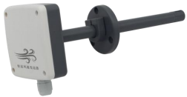
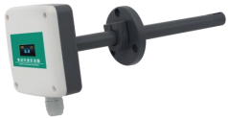

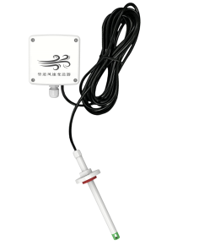

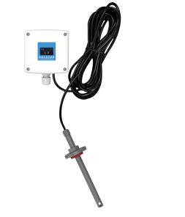

Chapter 1 Product Introduction

1.1 Product Overview
The transmitter is designed for pipeline wind speed measurement. The high-precision wind speed measurement unit is sensitive and can quickly and accurately measure small wind speed, with good stability, small drift and high accuracy. The transmitter can also calculate the real-time air volume value according to the measured pipeline cross-sectional area. Pipeline installation mode, site installation is convenient, the product adopts anti-interference circuit design, can withstand various strong electromagnetic interference such as field inverter, the equipment uses imported screw-free terminal wiring, more convenient to use.

1.2 Functional features
■ High-precision wind speed measurement unit, start the wind speed is small, sensitive response, can be suitable for ventilation pipe, lampblack pipe and other harsh environmental occasions;
■ Using the company independently developed the full-range secondary calibration method, good linearity, high accuracy;
■ Open-type flange installation, using high quality silicone sealing ring, small air leakage, durable;
■ The measured cross-sectional area of the pipeline can be set, and the real-time air volume value can be uploaded according to the set cross-sectional area;
■ 485 communication interface, standard ModBus-RTU protocol, communication address, port rate can be set, communication line up to 2000 meters;
■ Device address support software configuration and dial switch setting two ways;
■ The accuracy of range 0~ 10m / s is ± (0. 1 + 2%FS); range 0~ 15m / s, 0~20m / s, 0 ~ 30 m/s is ± (0.2 + 2%FS) m / s;
■ The wiring terminal adopts imported screw-free terminal, with no tools, as long as one pressure and one plug can be connected;
■ Using special EMC anti-interference devices, can withstand the field frequency converter and other strong electromagnetic interference;
■ There are two types of DC and DC power supply, and can realize long-distance centralized power supply;
■ With wind speed identification direction, easy for site installation.

1.3 Main parameters

DC-type equipment power supply | 10-30V DC
AC / DC type equipment power supply | 24V ( 20%~+ 10%)AC / 19-30V DC
maximum power dissipation | DC type | 0W.5
maximum power dissipation | CrossDC type | 2W.4
Measurement medium | Air, nitrogen, lampblack exhaust gas
accuracy | ± (0.2+2%FS ) m /s
Transmitter circuit operating temperature | - 10℃~+50℃
communicating protocol | Modbus-RTU, the communication protocol

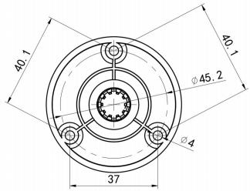

output signal | 485 Signal
Wind speed shows the resolution | 0. 1m/s
response time | 2S
long term stability | ≤0. 1m/s/year
parameter setting | Through the software settings
Shell size
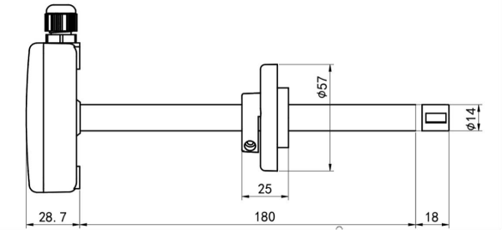
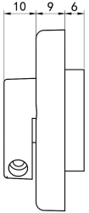

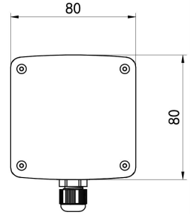

.41 System framework diagram

The product can also be used with multiple sensors in a 485 bus, theoretically one bus can be 254 485 sensors, 485 on the other end, interface PLC, 485 interface chip, or use USB to 485 to connect to the computer, using our sensor configuration tool for configuration and test (only one device can be connected when using the configuration software).

Chapter 2: Hardware Connection

.12 Check the equipment before installation
equipment list:
■ 1 set of transmitter equipment
■ 3 self-tapping screw and expansion plug each
■ Qualification certificate, warranty card

.22 Interface description
DC type: wide voltage of 10~30V DC power supply input;
AC / DC type: DC voltage 19~30V power input, AC voltage 24V (-20%~ + 10%) power input.485 When wiring the signal line, note that the two lines A \ B cannot be connected backwards, and the addresses of multiple devices on the bus cannot be conflicting.

2.2.1, Sensor wiring
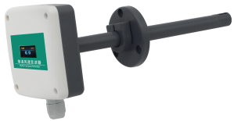
DC-type equipment:

order number | Internal identification | explain
1 | A | 485-A
2 | V + | Power positive
3 | GND | Power negative
4 | B | 485-B

AC / DC type equipment:

order number | Internal identification | explain
1 | A | 485-A
2 | V + | AC / power supply positive
3 | -  V | AC / power supply negative
4 | B | 485-B

2.3, Installation method
Note that it needs to be installed on the side or below the pipe, and it can not be installed from top to bottom.
First, make a 20mm diameter hole in the ventilation pipe, insert the air duct into the hole, adjust the direction of the equipment so that the arrow direction of the equipment is consistent with the direction of the wind speed, and the height of the equipment can be controlled by adjusting the position of the flange. Install the three screws to the flange plate, fix the equipment, and complete the installation.

The installation diagram is shown below:
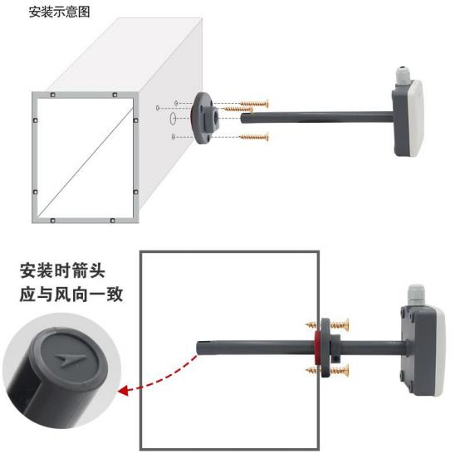

.23 The use of the sensor monitoring software
①, The configuration interface is shown in the figure. First, obtain the string slogan and select the correct serial port.
②, Click on the test port rate of the software, the software will test the port rate and address of the current device, the default port rate is 4800bit / s and the default address is 0x 01.
③, Change the address and port rate according to the use needs, and can query the current functional status of the device.
④. If the test is unsuccessful, please re-check the equipment wiring and 485 drive installation.

Chapter 4: Communication Protocol

.14. Basic parameters of communication

code | The 8-bit binary
data bit | Eight
parity check bit | not have
stop bit | One
error check | CRC (redundant cycle code)
Baud rate | 1200bit / s, 2400bit / s, 4800 bit/s, 9600 bit/s, 19200 bit/s, 38400 bit/s, 57600bit / s, 115200bit / s can be set, the factory default is 4800bit / s

.24 Data frame format definition
Adopt the Modbus-RTU communication protocol in the following format:
Time for the initial structure of the 4 bytes
Address code = 1 byte
Function code = 1 byte
Data area = N bytes
Error check = 16-bit CRC code
End the structure 4 bytes
Address code: is the address of the transmitter, which is unique in the communication network (factory default 0x 01). Function code: instructions issued by the host.
Data area: data area is specific communication data, note 16bits data high byte in front!
CRC code: a two-byte check code.
Host inquiry frame structure:

address code |  | FC |  | Register start address | register length |  | Calibration code low |  | Calibration code high
1 Bytes |  | 1 Bytes |  | 2 Bytes | 2 Bytes |  | 1 Bytes |  | 1 Bytes
Deliver answer frame structure:

address code | FC | Number of valid bytes | Data area 1 | Second data area | Data area # N | check code
1 Bytes | 1 Bytes | 1 Bytes | 2 Bytes | 2 Bytes | 2 Bytes | 2 Bytes

.34. To address the register address

Register address | The PLC or the configuration address | content | support  FC | explain
0000 H | 40001 | Current wind speed value  (m/s) | 0x 03 | Actual values of 10 times
0001 H | 40002 | Current volume integer value  (unit of m³/h) | 0x 03 | Range 0 to 65535, maximum 65535, over 65535 shows 65535
0002 H | 40003 | Current floating point value is 16 bits higher ( m³ /h) | 0x 03 | A decimal place
0003 H | 40004 | Current air volume floating point value 16 bits lower (unit m ³/h) | 0x 03 | A decimal place
0200 H | 40513 | Current pipe cross-sectional area  ( unit cm 2) | 0x 03/0x 06 | Range from 0 to 65535
07D 0 H | 42001 | device address | 0x 03/0x 06 | 1~254 (factory default 1)
07D1H | 42002 | Device Porter rate | 0x 03/0x 06 | 0 stands for 2,400  1 represents the representative of 4,800  2 representing 9600  3 stands for 19,200  4, representing 38,400  5 represents 57600  6, representing 1,15,200  7 represent 1200

.44 Device address setting mode
Device address support software configuration and dial switch setting two ways, only one way to set the address.
When the four dial switches are dialed to "OFF" file to support the address with the configuration software, the address can be set through "Configuration Software".
When the four dial switches have one in the ON " position, the device address can only be represented by the dial switch, the address set by the software is invalid, and the address range set by the dial switch is 1 to 15.
The address of the dial switch is set as follows: 1 represents ON and 0 represents OFF.

Modbus Address | 1 | 2 | 3
Address set by the software | 0 | 0 | 0 | 0
1 | 0 | 0 | 0 | 1
2 | 0 | 0 | 1 | 0
...... | ...... | ...... | ...... | ......
15 | 1 | 1 | 1 | 1

4.5 Example and explanation

4.5.1 Read the wind speed value of the device address 0x 01
Inquiry frame (16 x):

address code | FC |  | start address |  | DL | Calibration code low | Calibration code high
0x 01 | 0x 03 |  | 0x 00 0x 00 |  | 0x 00 0x 01 | 0x 84 | 0x 0A
Response frame (16 pr): (e. g. read wind speed of 10.8m/s)

address code |  | FC |  | Returns a valid number of bytes |  | Wind speed value | Calibration code low |  | Calibration code high
0x 01 |  | 0x 03 |  | 0x 02 |  | 0x 00 0x 6C | 0xB 8 |  | 0x 69
Wind speed calculation:
Wind speed: 006 CH (hexadecimal) = 108 => Wind speed = 10.8m / s

4.5.2 Read the current pipe cross-sectional area of the device address 0x01
Inquiry frame (16 x):

address code | FC | start address |  | DL | Calibration code low |  | Calibration code high
0x 01 | 0x 03 | 0x 02 0x 00 |  | 0x 00 0x 01 | 0x 85 |  | 0xB 2
Response frame (16 c): (e. g. read pipe 100 cm 2)

address code |  | FC |  | Returns a valid number of bytes | Wind speed value | Calibration code low |  | Calibration code high

0x 01 |  | 0x 03 |  | 0x 02 | 0x 00 0x 64 | 0x 89 |  | 0x 99

Calculation of pipe cross-sectional area:
Wind speed: 0064 H (hex system) = 100=>, pipeline cross-sectional area = 100 square centimeters

4.5.3 Set the pipeline cross-sectional area of 200, square cm, of the equipment address 0x 01
Request frame (16 x):
address code | FC | start address |  | Data content | Calibration code low |  | Calibration code high
0x 01 | 0x 06 | 0x 02 0x 00 |  | 0x 00 0xC 8 | 0x 89 |  | 0xE 4
Response frame (16 c): (e. g. read pipe 100 cm 2)
address code |  | FC |  | start address | Data content |  | Calibration code low | Calibration code high
0x 01 |  | 0x 06 |  | 0x 02 0x 00 | 0x 00 0xC 8 |  | 0x 89 | 0xE 4
Set the pipe section area calculation:
Wind speed: 00C 8 H (hexadecimal) = 200=>, pipeline cross-sectional area = 200 square centimeters

4.5.4 Read the current air volume integer value for the device address 0x01
Current air volume value calculation formula:
Current air volume value = current wind speed value (per meter per second) Pipe cross-sectional area (per square centimeter) 360010000. Inquiry frame (16 x):

address code | FC | start address |  | DL | Calibration code low |  | Calibration code high
0x 01 | 0x 03 | 0x 00 0x 01 |  | 0x 00 0x 01 | 0xD 5 |  | 0xCA
Response frame (16 x): (e. g. read air volume integer 545m ³ / h)

address code |  | FC | Returns a valid number of bytes | Wind volume integer value |  | Calibration code low |  | Calibration code high
0x 01 |  | 0x 03 | 0x 02 | 0x 02 0x 21 |  | 0x 79 |  | 0x 3C
Calculation of air volume integer value:
Integer value: 0221 H (hex) = 545=>, integer value = 545m ³ / h

.44.5 Read the current air volume floating point value of the device address 0x01
Current air volume value calculation formula:
Current air volume value = current wind speed value (per meter per second) Pipe cross-sectional area (per square centimeter) 360010000. Floating-point data retain one effective decimal place.
Inquiry frame (16 x):

address code |  | FC | start address | DL |  | Calibration code low |  | Calibration code high

0x 01 |  | 0x 03 | 0x 00 0x 02 | 0x 00 0x 02 |  | 0x 65 |  | 0xCB

Response frame (16 x): (e. g. 545.2m ³ / h)

address code |  | FC | Return valid  Byte number | Air volume floating point type  High 16 | Air volume floating point type  Lower at the 16th position |  | Calibration code low | Calibration code high
0x 01 |  | 0x 03 | 0x 04 | 0x 44 0x 08 | 0x 4C 0xCD |  | 0x 9A | 0x 54
Calculation of air volume:
Floating point value: 44084CCD H (hexadecimal) = 545.2=> Wind volume floating point value = 545.2m ³ / h

Chapter 5: Common Problems and Solutions
No output or output errors
probable cause:
1) The computer has multiple COM ports and the port mouth is incorrect.
2) The equipment address is wrong, or there are duplicate address equipment (the factory default is 1).
3) Baud rate, check mode, data bit, and stop bit error.
4) The host polling interval and waiting response time are too short, which should be set above 200ms.
5) 485 The bus is disconnected, or lines A and B are connected.
6) If the number of equipment is too much or the wiring is too long, the power supply nearby, 485 enhancer should be added, and 120 Ω terminal resistance should be added.
7) USB to 485 driver is not installed or damaged.8) The power supply voltage is wrong (the DC voltage of AC / DC equipment should be greater than 19V, and the AC voltage must be 24V (-20%~ + 10%)).
9) Equipment damage.

