**Polycarbon wind speed transmitter**

**(Type 485)**

**Chapter 1 Product Introduction**

**1.1 Product overview**

The wind speed transmitter adopts the traditional three wind cup wind speed sensor structure, the wind cup is made of carbon fiber material, which has high strength and good start; the built-in signal processing unit of the cup body can output the corresponding wind speed signal according to user needs, and can be widely used in meteorology, ocean, and environment , Airports, ports, laboratories, industry, agriculture and transportation.

**1.2 Features**

* Range: 0-70m/s, resolution 0.1m/s

* Anti-electromagnetic interference treatment

* The bottom outlet method is adopted to completely eliminate the aging problem of aviation plug rubber pads, and it is still waterproof after long-term use

■ *Use high-performance imported bearings, low rotation resistance, accurate measurement

■ *Polycarbonate shell, high mechanical strength, high hardness, corrosion resistance, no rust, and long-term use outdoors

■ *The structure and weight of the equipment are carefully designed and distributed, with low moment of inertia and sensitive response

■ *Standard ModBus-RTU communication protocol, easy to access

**1.3 Main parameters**

|  |  |
| --- | --- |
| DC power supply (default) | 10~30V DC |
| Power consumption | ≤0.3W |
| Transmitter circuit operating temperature | -20℃~+60℃，0%RH~80%RH |
| Communication Interface | 485 communication (modbus) protocol  Baud rate: 2400, 4800 (default), 9600  Data bit length: 8 bits  Parity check method: none  Stop bit length: 1 bit  Default ModBus communication address: 1  Support function code: 03/04 |
| parameter settings | Use the provided configuration software to configure through the 485 interface |
| Resolution | 0.1m/s |
| Precision | ±（0.2+0.03V）m/s V means wind speed |
| Measuring range | 0~70m/s |
| Dynamic response time | ≤0.5s |
| Starting wind speed | ≤0.2m/s |

**Shell size**

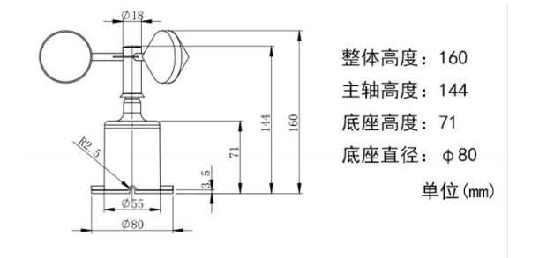

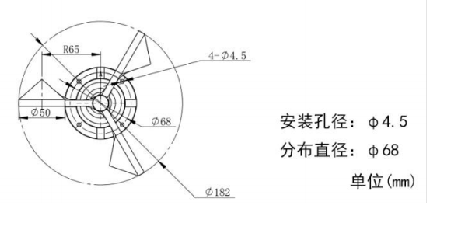

**Chapter 2 Hardware Connection**

**2.2 Interface description**

The power interface is a wide voltage power input, 10-30V can be used. When wiring the 485 signal wire, pay attention to the two wires A\B not reversed, and the addresses of multiple devices on the bus cannot conflict.

**2.2.1 Sensor wiring**

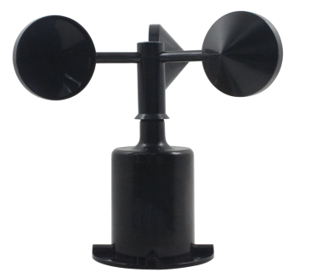

|  |  |  |
| --- | --- | --- |
|  | Thread color | Description |
| power supply | brown | Positive power supply (10~30V DC) |
| Black | Power negative |
| Communication | Green | 485-A |
| Blue | 485-B |

**2.3 Installation method**

Flange installation is adopted. The threaded flange connection makes the lower pipe fitting of the wind speed sensor firmly fixed on the flange. The chassis is Ø65mm. Four mounting holes of Ø6mm are opened on the circumference of Ø47.1mm, and the bolts are used to fix it tightly. The bracket keeps the whole set of instruments at the best level to ensure the accuracy of wind speed data. The flange connection is easy to use and can withstand greater pressure.

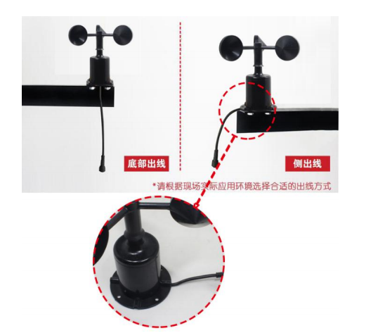

**2.4 Matters needing attention**

1. Users are not allowed to disassemble by themselves, let alone touch the sensor core, so as not to cause damage to the product.

2. Keep away from high-power interference equipment as far as possible to avoid inaccurate measurement, such as inverters, motors, etc., when installing or disassembling the transmitter, you must first disconnect the power supply. Water in the transmitter can cause irreversible changes.

3. Prevent chemical reagents, oil, dust, etc. from directly invading the sensor, do not use it for a long time under condensation and extreme temperature environments, and prevent thermal shock.

**Chapter 3 Configuration Software Installation and Use**

Our company provides the supporting "485 parameter configuration software", which can easily use the computer to read the parameters of the sensor, and at the same time flexibly modify the device ID and address of the sensor.

Note that you need to ensure that there is only one sensor on the 485 bus when using the software to obtain it automatically.

**3.1 Connect the sensor to the computer**

After the sensor is correctly connected to the computer via USB to 485 and supplied with power, you can see the correct COM port in the computer (check the COM port in "My Computer—Properties—Device Manager—Port").

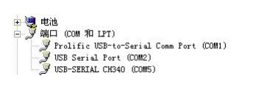

Open the data package, select "Debugging Software" --- "485 Parameter Configuration Software", find and open it. 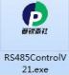

**3.2 Use of sensor monitoring software**

①. The configuration interface is shown in the figure. First, obtain the serial port number according to the method in chapter 3.1 and select the correct serial port.

②. Click the test baud rate of the software, the software will test the baud rate and address of the current device, the default baud rate is 4800bit/s, and the default address is 0x01.

③. Modify the address and baud rate according to the needs of use, and at the same time query the current function status of the device.

④. If the test is unsuccessful, please recheck the equipment wiring and 485 driver installation.

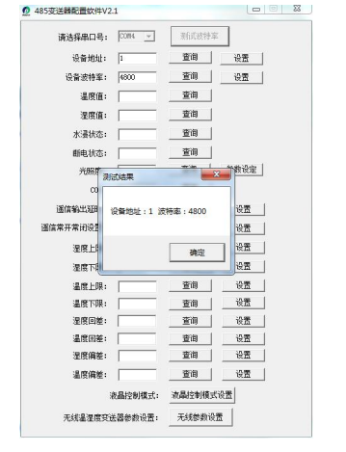

**Chapter 4 Communication Protocol**

**4.1 Basic communication parameters**

|  |  |
| --- | --- |
| Code | 8-bit binary |
| Data bit | 8-bit |
| Parity bit | no |
| Stop bit | 1 bit |
| Error checking | CRC (Redundant Cyclic Code) |
| Baud rate | 2400bit/s, 4800bit/s, 9600 bit/s can be set, the factory default is 4800bit/s |

**4.2 Data frame format definition**

Using Modbus-RTU communication protocol, the format is as follows:

Initial structure ≥ 4 bytes of time

Address code = 1 byte

Function code = 1 byte

Data area = N bytes

Error check = 16-bit CRC code

Time to end structure ≥ 4 bytes

Address code: the address of the transmitter, which is unique in the communication network (factory default 0x01).

Function code: the command function instruction issued by the host, this transmitter only uses the function code 0x03 (read register number

according to).

Data area: The data area is the specific communication data, pay attention to the high byte of 16bits data first!

CRC code: two-byte check code.

Host query frame structure:

|  |  |  |  |  |  |
| --- | --- | --- | --- | --- | --- |
| address code | function code | Register start address | Register length | Check code low bit | High bit of check code |
| 1 byte | 1 byte | 2 byte | 2 byte | 1 byte | 1 byte |

Slave machine response frame structure:

|  |  |  |  |  |  |  |
| --- | --- | --- | --- | --- | --- | --- |
| address code | function code | Number of valid bytes | Data area | Second data area | Data area N | Check code |
| 1 byte | 1 byte | 1 byte | 2 byte | 2 byte | 2 byte | 2 byte |

**4.3 Register address**

|  |  |  |  |
| --- | --- | --- | --- |
| Register address | PLC or configuration address | content | operating |
| 0000 H | 40001 | Instantaneous wind speed  Uploaded data is 10 times the real value | Read only |

**4.4 Communication protocol example and explanation**

Example: Read the wind speed value of the device address 0x01

Interrogation frame:

|  |  |  |  |  |  |
| --- | --- | --- | --- | --- | --- |
| address code | function code | starting address | Data length | Check code low bit | High bit of check code |
| 0x01 | 0x03 | 0x00 0x00 | 0x00 0x01 | 0x84 | 0x0A |

|  |  |  |  |  |  |
| --- | --- | --- | --- | --- | --- |
| address code | function code | Returns the number of valid bytes | Current wind speed value | High bit of check code | High bit of check code |
| 0x01 | 0x03 | 0x02 | 0x00 0x56 | 0x38 | 0x7A |

Wind speed calculation:

Current wind speed: 0056H (hexadecimal) = 86=> wind speed = 8.6m/s

Chapter 5 Common Problems and Solutions

No output or output error

possible reason:

①. The computer has a COM port, and the selected port is incorrect.

② The baud rate is wrong.

③ The 485 bus is disconnected, or the A and B wires are connected reversely.

④. If the number of equipment is too much or the wiring is too long, power supply should be nearby, add a 485 booster, and add a 120Ω terminal resistance.

⑤ The USB to 485 driver is not installed or damaged.

⑥ The equipment is damaged.